Deye Copilot: AI-Powered Energy Management & Application Guide

We're delighted to announce the release of Deye Cloud Ver.3.0.0 from January 2025.
Introducing the future of energy management: the Deye Cloud Copilot, powered by advanced AI technology. This cutting-edge system revolutionizes how you interact with your energy, providing smart, automated insights and controls that optimize efficiency and performance. Seamlessly integrate your Deye inverters with our intelligent Cloud Copilot, and experience real-time monitoring, predictive grid savings and Grid selling forecast, and enhanced energy decisions all at your fingertips. Elevate your energy management with Deye Cloud Copilot...
The upgraded Deye Cloud will bring you powerful new features：
・Deye Copilot:minimizes the electricity tariff by optimize battery charging and discharging time period settings.
・Customized AI Chatbot Support:pre＆after-sales Deye AI Chatbot support to satisfied users demands.
・Support local mode for three-phase HV devices.

Before applying, ensure your equipment and plant meet these requirements:
Hardware Requirements: Deye solar inverter and any brand battery
Software Requirements: Deye Cloud App
Plant Requirements: Rate Plan Must Be Configured

1. Setting Tariffs
There are three ways to set tariffs:
- For first-time setup: Go to Plant Details Page, tap the Menu Button (top right), then select "Edit Rate Plan" to configure your rates.
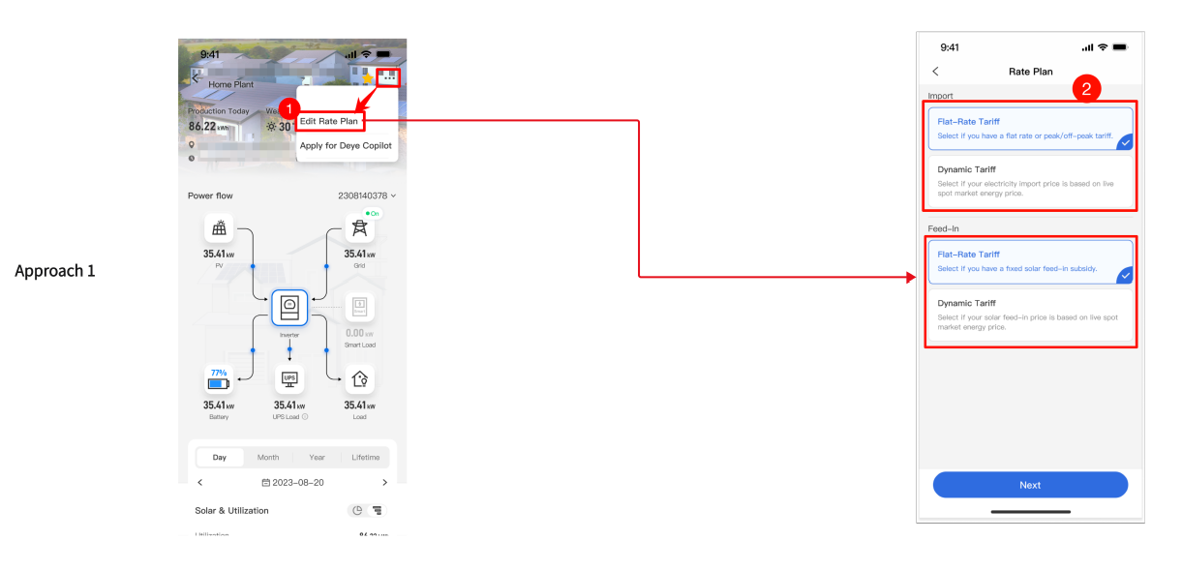
- After submitting your Copilot application form, you can also access tariff settings directly from the results page.
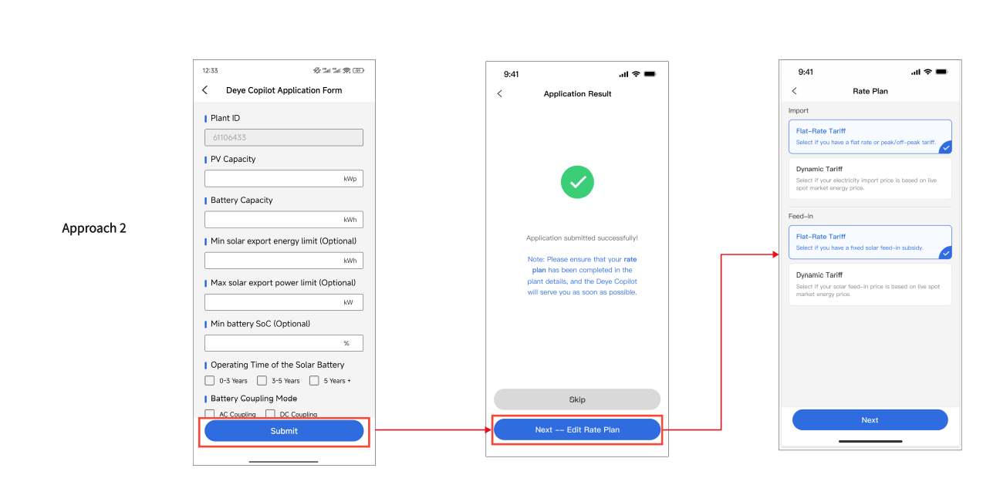
- For existing tariffs, click the tariff area next to "Weather" on the Plant overview page to access settings directly. Follow the on-screen prompts to complete your configuration.
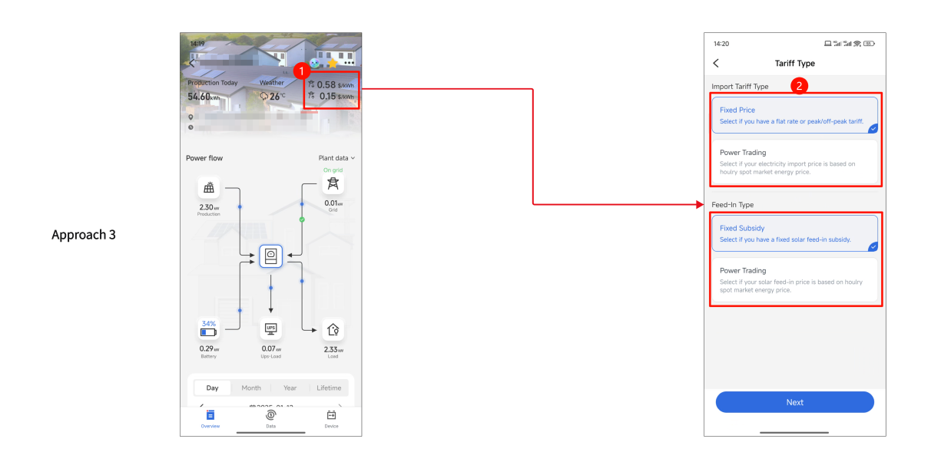

2. Deye Cloud Copilot Application Process
Step 1: Log in to the Deye Cloud app and go to the plant details page where you want to activate Deye Cloud Copilot.
Step 2: Click the menu button in the top right corner and select "Apply for Deye Copilot."
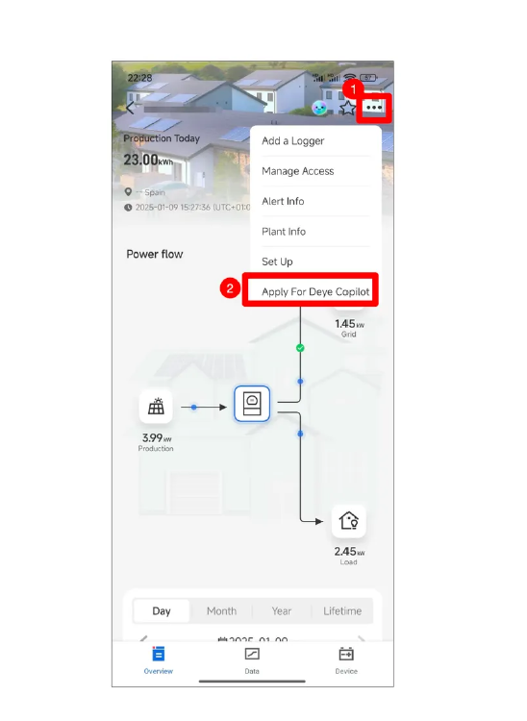
Step 3: Complete all required fields and submit your application. Review takes 1-2 business days. After submitting, you can either set up your rate plan by clicking "Next - Edit Rate" or click "Skip" if you've already configured rates.
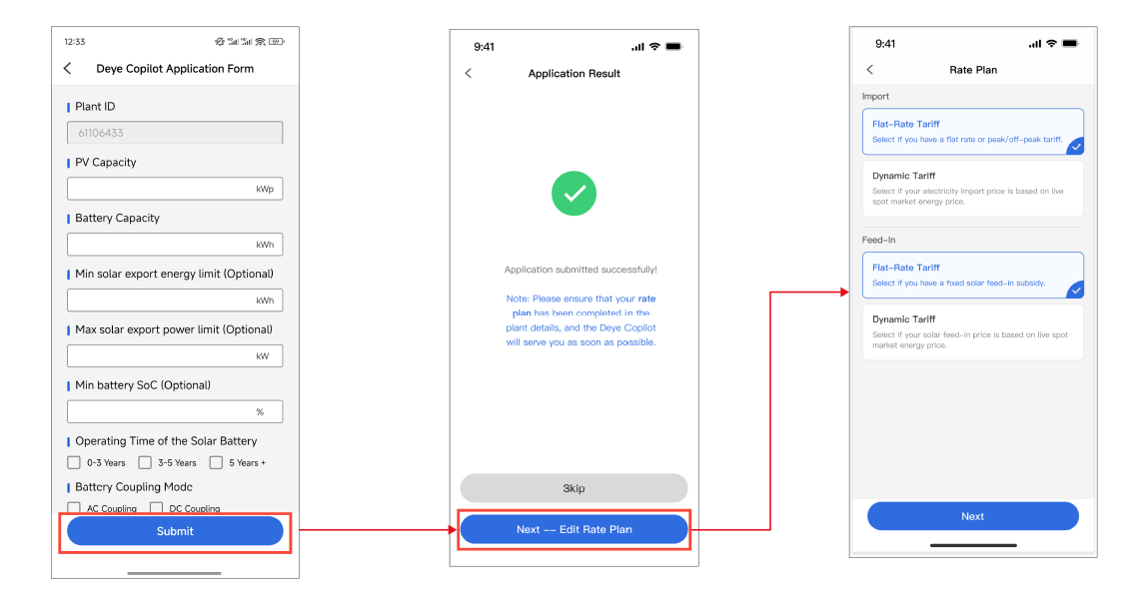
Step 4: After approval, Deye Copilot activates automatically for your plant. You'll receive a confirmation message in the "Message Center." You can verify activation by checking the control mode at the bottom of your plant's "Data" page (shown in the image). A Copilot icon will also appear on your plant card on the homepage.
